**Key Topics** **Covered**

**NUnit :** Using **OneTimeSetUp**, **OneTimeTearDown**, **SetUp** and **TearDown**

**Web elements** : Dropdown(single selection and multiple selection), scroll bar, input fields, buttons, tabs, tables, iframes,

**Driver Components** : Add Capabilities (Incognito, Download Options), Waits (Explicit/Implicit/Fluent)

**Browser Functionalities** : Creating new tabs and switching between and closing them,, Upload and Download, Reading downloaded Files

***Test Websites:***

1. For Assignments

<http://the-internet.herokuapp.com/>

1. For Classwork

<https://phptravels.net>

* 1. User types : User, Admin, Supplier
  2. Credentials and URLs for all three users : <https://phptravels.com/demo.php/>

**Section 1 : ASSIGNMENTS**

## Wait

1. Go to the url : <http://the-internet.herokuapp.com/dynamic_loading/2>
2. Click Start Button
3. Wait (Use Explicit Wait) until the loading message disappears

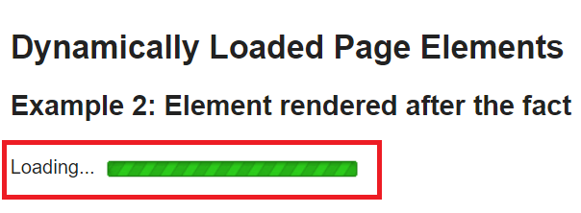

1. Verify the message ‘Hello World!’ is getting displayed after the Loading message disappears

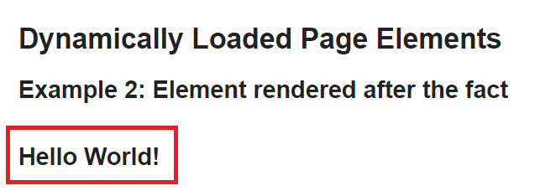

## File Upload

1. Navigate to this url : <http://the-internet.herokuapp.com/upload>
2. Click on ‘Choose File’ button
3. Upload any text file from your system

(Hint : You need to pass the complete filepath)

1. Verify that the uploaded file name is shown next to the ‘Choose File’ button like below :

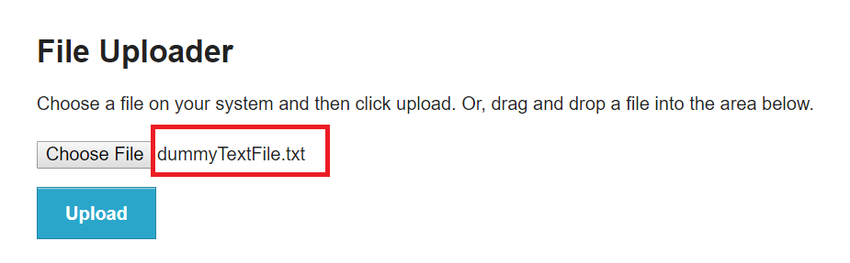

## Hovers

1. Navigate to this URL : <http://the-internet.herokuapp.com/hovers>
2. There are three images shown in the application. Hover the mouse over each image and verify the detail below.

For example in the screenshot below, user hovers over the first image and the detail appears below saying ‘name: user1’

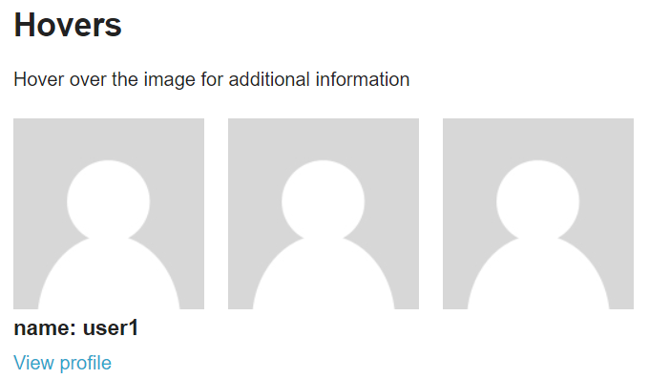

Do this for the second and third image as well and click on the ‘View Profile’ link for each image.

For example, clicking on ‘View Profile’ on first image, takes the user to User 1’s page. Which has the url as : <http://the-internet.herokuapp.com/users/1>.

Verify clicking on ‘View Profile’ of User2 and User3 will redirect the users to URLs which are [http://the-internet.herokuapp.com/users/](http://the-internet.herokuapp.com/users/1)2 and [http://the-internet.herokuapp.com/users/](http://the-internet.herokuapp.com/users/1)3

## Sorting Table Columns

1. Go to the url : <http://the-internet.herokuapp.com/tables>
2. See the table under ‘Example 1’. Click on the first column header named ‘Last Name’ and verify whether the values are ordered in ascending order like below.

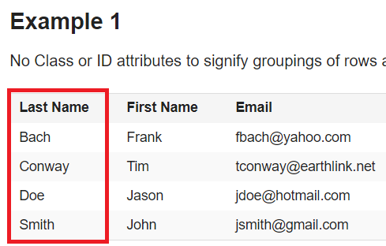

Click the column name again and verify whether the order is now descending like below :

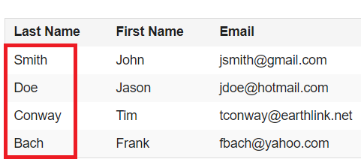

## Drag and Drop

1. Go to url : <http://the-internet.herokuapp.com/drag_and_drop>
2. There will be two squares A and B
3. Drag square A to the position of square B like below :

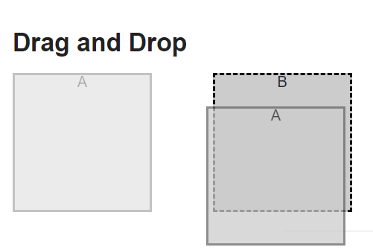

1. Verify whether the square positions are swapped like below :

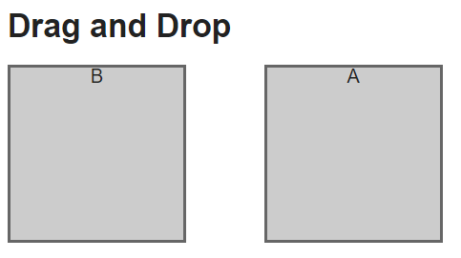

## Window Handles

1. Go to the url : <http://the-internet.herokuapp.com/windows>
2. Clicking on the ‘Click Here’ button opens up a new tab window

Click on this link 5 times to open up 5 new tabs like below :

1. Verify that the count of total open windows is :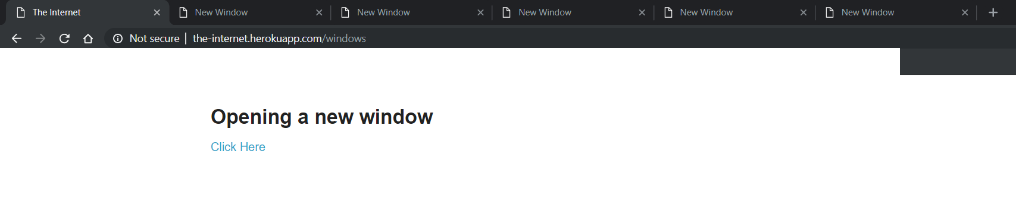

6 tabs (5 new tabs + 1 initial tab )

## File Download

1. Go to this url : <http://the-internet.herokuapp.com/download>
2. Click on any file link to perform the download
3. Verify whether the file was successfully downloaded or not

(Hint : You can use FileExists function in C#)

## IFrame Input

1. Go to : <http://the-internet.herokuapp.com/iframe>

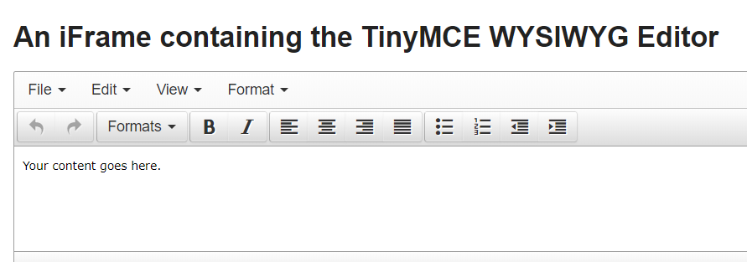

1. Inside the input text area clear the initial content which says ‘Your content goes here.’

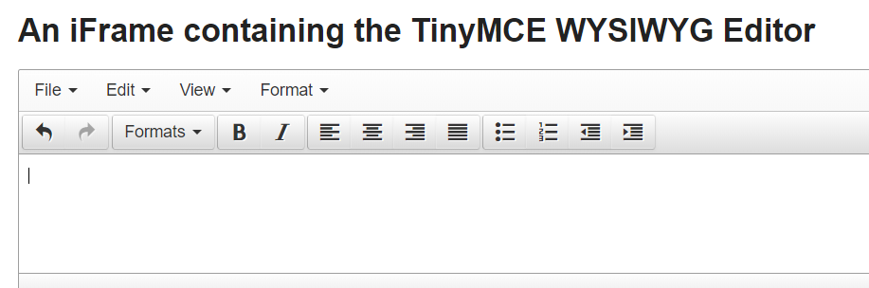

1. Verify whether the text that you entered is correctly getting displayed

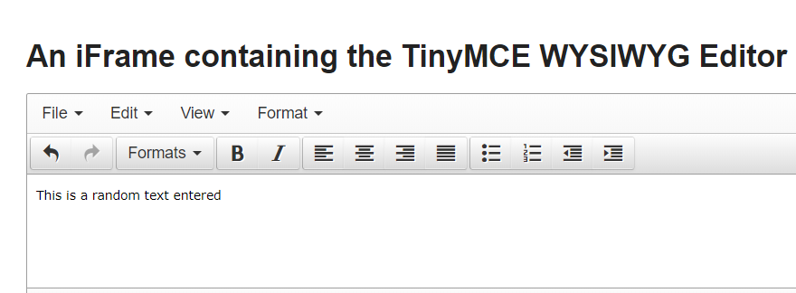

## Dynamic Controls -- 1

1. Go to : <http://the-internet.herokuapp.com/dynamic_controls>
2. Click on ‘Remove’ button

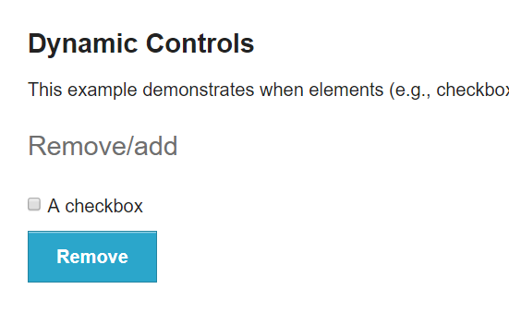

3. Verify whether the checkbox is removed after the button is clicked

## Dynamic Controls --2

1. Go to : <http://the-internet.herokuapp.com/dynamic_controls>
2. Verify the input box is disabled by default
3. Click on ‘Enable’ button and Verify that the input box is now enabled
4. Click on the ‘Disable’ button again and verify whether the input field is now disabled

**Section 2 :**

1. **PhpTravels.NET**
2. Log in as an admin user. The admin should be directed to the dashboard page by default. Check the value of ‘Today’s Bookings’.

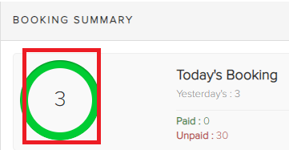

1. Click on ‘Quick Booking’ button on the Dashboard page which should present a popup modal. Select ‘Hotels’ in the Service dropdown in the popup and click Next.
2. The Quick Booking form page should open up.

Enter the following details in the form :

1. By default the Customer Name field should show **Johny Smith -user@phptravels.com**. Leave this unchanged.
2. Enter a check in date and check-out date. Verify if the Total (Nights) text box shows the correct number of nights depending upon the entered dates.
3. On the Hotel Name dropdown, type in this text ‘Grand’.’ Which should show ‘Grand Plaza Apartments’ in the dropdown. Click this option.

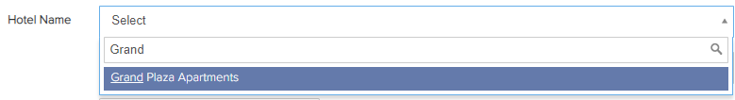

1. In ‘Room Quality’ dropdown, select any option without entering a text.
2. In the text field ‘Per Night Price’ enter 100. In the ‘Total Deposit’ field, enter 50.
3. In the ‘Booking Summary’ section on the side, verify the Grand Total is equal to this formula :

Grand Total = (Price Per Night X Total Nights) + (Tax & VAT)

In the example below,   
Grand Total = 7 nights X 100 price per night + 35 tax = 735

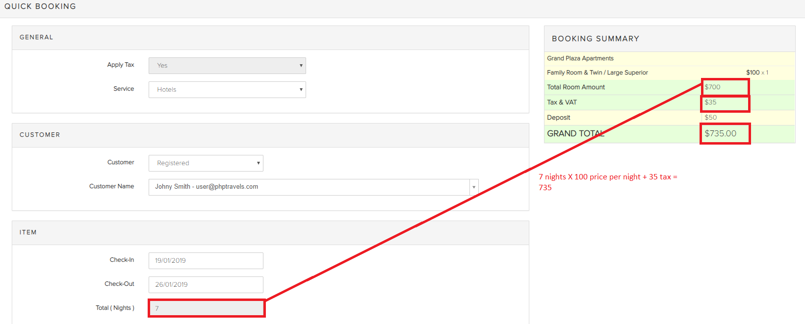

1. Click ‘Book Now’ button
2. Return back to the Dashboard Page
3. Verify that the ‘Today’s Booking’ value now should be greater than it was before (in step 1)

